## PROJECT REPORT

### On

**SOCIAL NETWORK PROTOTYPE**

Submitted to MAHARAJA RANJIT SINGH PUNJAB TECHNICAL

UNIVERSITY in partial fulfillment of the requirement for the award of the degree of

**B.TECH**

**in**

## COMPUTER SCIENCE & ENGINEERING

**Submitted By**

## Sakshi Kumari

**(190280105)**



### DEPARTMENT OF COMPUTER SCIENCE & ENGINEERING

**GIANI ZAIL SINGH CAMPUS COLLEGE OF ENGINEERING& TECHNOLOGY, MRSPTU, BATHINDA-151001**

**MAY 2023**

1

## PROJECT REPORT

### On

**SOCIAL NETWORK PROTOTYPE**

Submitted to MAHARAJA RANJIT SINGH PUNJAB TECHNICAL

UNIVERSITY in partial fulfillment of the requirement for the award of the degree of

**B.TECH**

**in**

## COMPUTER SCIENCE & ENGINEERING

**Submitted By**

## Sakshi Kumari

**(190280105)**



### DEPARTMENT OF COMPUTER SCIENCE & ENGINEERING

**GIANI ZAIL SINGH CAMPUS COLLEGE OF ENGINEERING& TECHNOLOGY, MRSPTU, BATHINDA-151001**

**MAY 2022**

## PREFACE

Project is an integral part of B.Tech and each and every student has to work on a project in their field. This record is concerned about our practical project work during the 8th semester of our B.Tech. We have worked on our practical project in Android App Development during this semester. We got to learn many new things about the challenges that are faced in the working of projects and the current requirements of companies. This project proved to be a milestone in our knowledge of the present industry. Everyday and every moment was an experience in itself, an experience which theoretical study can’t provide.

## ACKNOWLEDGEMENT

It was our pleasure to be indebted to various people, who directly or indirectly contributed in the development of this work and who influenced my thinking, behavior and acts during the course of study.

We express our sincere gratitude to **Er. Jyoti Rani** worthy HOD and our project guide for 8th semester and Department Training and Placement for providing us time slots in the time table of our current semester for us to work on our projects and assigning us best project guide for the process.

And all the people’s who have helped us and guided us we are thankful to all for your support, cooperation, and motivation provided to us during the making of this project.

Lastly, I would like to thank the almighty and my parents for their moral support and my friends with whom I shared my day-to-day experience and received lots of suggestions that my quality of work

## SAKSHI KUMARI

## (190280105)

**CANDIDATE’S DECLARATION**

I, **Abhishek Kumar(99190280001), Digvijay(99190280001)** B.Tech (Semester- VIII) of the **Gaini Zail Singh Campus College of Engineering & Technology, Bathinda** hereby declare that the Training Report entitled “Social Network Prototype” is an original work and data provided in the study is authentic to the best of our knowledge. This report has not been submitted to any other Institute for the award of any other degree.

**Sakshi Kumari**

(190280105)

**Place: Bathinda Date: 18-05-2023**

# TABLE OF CONTENTS

1. INTRODUCTION TO PROJECT 7
   1. PURPOSES 9
2. JAVASCRIPT 10
   1. INTRODUCTION 10
   2. OBJECTIVES 10
3. HTML 12
   1. INTRODUCTION 12
4. **CSS…………………………………………………………………………........**15

4.1 INTRODUCTION…………………………………………………………...16

1. SNAPSHOTS 30
2. CONCLUSION 43
3. BIBLOGRAPHY 44

# CHAPTER-1

# INTRODUCTION TO PROJECT

This Network Prototype is in full JavaScript and HTML. Talking about the project, it contains a user side from where a user can view, share a post, photos and many more. The users play an important role in the management of this social media site. In this project, all the main functions have to be performed from the user side.This is a simple demo model for social media sites. You can use session storage and local storage function to set the data as default value.

#### About the system

Talking about the features of the Social Network prototype, the user can view/manage post just by typing text and sharing it. It’s almost like using other popular social media. It features adding photos, sending messages, searching and adding friends. Since this project is only a prototype model, you can perform every action in it. The user can also simply unfriend other users from his/her account.

**CHAPTER-2**

**JAVASCRIPT**

JavaScript (js) is a light-weight object-oriented programming language which is used by several websites for scripting the webpages. It is an interpreted, full-fledged programming language that enables dynamic interactivity on websites when applied to an HTML document. It was introduced in the year 1995 for adding programs to the webpages in the Netscape Navigator browser. Since then, it has been adopted by all other graphical web browsers. With JavaScript, users can build modern web applications to interact directly without reloading the page every time. The traditional website uses js to provide several forms of interactivity and simplicity.

Although, JavaScript has no connectivity with Java programming language. The name was suggested and provided in the times when Java was gaining popularity in the market. In addition to web browsers, databases such as CouchDB and MongoDB uses JavaScript as their scripting and query language.

## Features of JavaScript

There are following features of JavaScript:

1. All popular web browsers support JavaScript as they provide built-in execution environments.
2. JavaScript follows the syntax and structure of the C programming language. Thus, it is a structured programming language.
3. JavaScript is a weakly typed language, where certain types are implicitly cast (depending on the operation).
4. JavaScript is an object-oriented programming language that uses prototypes rather than using classes for inheritance.
5. It is a light-weighted and interpreted language.
6. It is a case-sensitive language.
7. JavaScript is supportable in several operating systems including, Windows, macOS, etc.
8. It provides good control to the users over the web browsers.

## Application of JavaScript

JavaScript is used to create interactive websites. It is mainly used for:

* Client-side validation,
* Dynamic drop-down menus,
* Displaying date and time,
* Displaying pop-up windows and dialog boxes (like an alert dialog box, confirm dialog box and prompt dialog box),
* Displaying clocks etc.

# JavaScript Objects

A javaScript object is an entity having state and behavior (properties and method). For example: car, pen, bike, chair, glass, keyboard, monitor etc.

JavaScript is an object-based language. Everything is an object in JavaScript.

|  |  |
| --- | --- |
| **jQuery** | **JavaScript** |
| It is a javascript library. | It is a dynamic and interpreted web-development programming language. |
| The user only need to write the required jQuery code | The user needs to write the complete js code |
| It is less time-consuming. | It is more time consuming as the whole script is written. |
| There is no requirement for handling multi-browser compatibility issues. | Developers develop their own code for handling multi-browser compatibility. |
| It is required to include the URL of the jQuery library in the header of the page. | JavaScript is supportable on every browser. Any additional plugin need not to be included. |
| It depends on the JavaScript as it is a library of js. | jQuery is a part of javascript. Thus, the js code may or may not depend on jQuery. |
| It contains only a few lines of code. | The code can be complicated, as well as long. |
| It is quite an easy, simple, and fast approach. | It is a weakly typed programming approach. |
| jQuery is an optimized technique for web designing. | JavaScript is one of the popular web designing programming languages for developers that introduced jQuery. |
| jQuery creates DOM faster. | JavaScript is slow in creating DOM. |

## Creating Objects in JavaScript

There are 3 ways to create objects.

1. By object literal
2. By creating instance of Object directly (using new keyword)
3. By using an object constructor (using new keyword)

# External JavaScript file

We can create external JavaScript file and embed it in many html page.

It provides **code re usability** because single JavaScript file can be used in several html pages.

An external JavaScript file must be saved by .js extension. It is recommended to embed all JavaScript files into a single file. It increases the speed of the webpage.

Let's create an external [JavaScript](https://www.javatpoint.com/javascript-tutorial) file that prints Hello Javatpoint in a alert dialog box.

**message.js**

1. function msg(){
2. alert("Hello Javatpoint");
3. }

Let's include the JavaScript file into [html](https://www.javatpoint.com/html-tutorial) page. It calls the [JavaScript function](https://www.javatpoint.com/javascript-function) on button click.

**index.html**

1. **<html>**
2. **<head>**
3. **<script** type="text/javascript" src="message.js"**></script>**
4. **</head>**
5. **<body>**
6. **<p>**Welcome to JavaScript**</p>**
7. **<form>**
8. **<input** type="button" value="click" onclick="msg()"**/>**
9. **</form>**
10. **</body>**
11. **</html>**

## Advantages of External JavaScript

There will be following benefits if a user creates an external javascript:

1. It helps in the reusability of code in more than one HTML file.
2. It allows easy code readability.
3. It is time-efficient as web browsers cache the external js files, which further reduces the page loading time.
4. It enables both web designers and coders to work with html and js files parallelly and separately, i.e., without facing any code conflictions.
5. The length of the code reduces as only we need to specify the location of the js file.

## Disadvantages of External JavaScript

There are the following disadvantages of external files:

1. The stealer may download the coder's code using the url of the js file.
2. If two js files are dependent on one another, then a failure in one file may affect the execution of the other dependent file.
3. The web browser needs to make an additional http request to get the js code.
4. A tiny to a large change in the js code may cause unexpected results in all its dependent files.
5. We need to check each file that depends on the commonly created external javascript file.
6. If it is a few lines of code, then better to implement the internal javascript code.

**CHAPTER 3**

**HTML**

INTRODUCTION:

* HTML stands for HyperText Markup Language.
* HTML is used to create web pages and web applications.
* HTML is widely used language on the web.
* We can create a static website by HTML only.
* Technically, HTML is a Markup language rather than a programming language.

1. **<html>**
2. **<head>**
3. **<script** type="text/javascript" src="message.js"**></script>**
4. **</head>**
5. **<body>**
6. **<p>**Welcome to JavaScript**</p>**
7. **<form>**
8. **<input** type="button" value="click" onclick="msg()"**/>**
9. **</form>**
10. **</body>**
11. **</html>**

# HTML Tags

HTML tags are like keywords which defines that how web browser will format and display the content. With the help of tags, a web browser can distinguish between an HTML content and a simple content. HTML tags contain three main parts: opening tag, content and closing tag. But some HTML tags are unclosed tags.

When a web browser reads an HTML document, browser reads it from top to bottom and left to right. HTML tags are used to create HTML documents and render their properties. Each HTML tags have different properties.

# HTML Attribute

* HTML attributes are special words which provide additional information about the elements or attributes are the modifier of the HTML element.
* Each element or tag can have attributes, which defines the behaviour of that element.
* Attributes should always be applied with start tag.
* The Attribute should always be applied with its name and value pair.
* The Attributes name and values are case sensitive, and it is recommended by W3C that it should be written in Lowercase only.
* You can add multiple attributes in one HTML element, but need to give space between two attributes.
* **Tags:** An HTML tag surrounds the content and apply meaning to it. It is written between < and > brackets.
* **Attribute:** An attribute in HTML provides extra information about the element, and it is applied within the start tag. An HTML attribute contains two fields: name & value.

## Syntax

1. **<tag** name  attribute_name= " attr_value"**>** content **</** **tag** name**>**

* **Elements:** An HTML element is an individual component of an HTML file. In an HTML file, everything written within tags are termed as HTML elements.

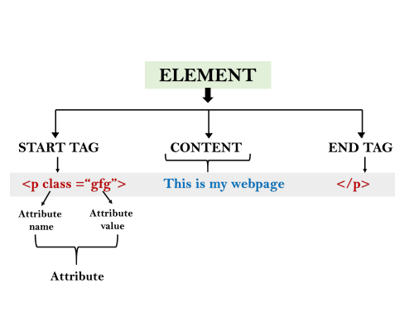

## Example:

1. <!DOCTYPE html**>**
2. **<html>**
3. **<head>**
4. **<title>**The basic building blocks of HTML**</title>**
5. **</head>**
6. **<body>**
7. **<h2>**The building blocks**</h2>**
8. **<p>**This is a paragraph tag**</p>**
9. **<p** style="color: red"**>**The style is attribute of paragraph tag**</p>**
10. **<span>**The element contains tag, attribute and content**</span>**
11. **</body>**
12. **</html>**

**Output:**

## The building blocks

This is a paragraph tag

The style is attribute of paragraph tag

The element contains tag, attribute and content

# HTML Image

**HTML img tag** is used to display image on the web page. HTML img tag is an empty tag that contains attributes only, closing tags are not used in HTML image element.

Let's see an example of HTML image.

1. **<h2>**HTML Image Example**</h2>**
2. **<img** src="good_morning.jpg" alt="Good Morning Friends"**/>**

Output:



## Attributes of HTML img tag

The src and alt are important attributes of HTML img tag. All attributes of HTML image tag are given below.

#### 1) src

It is a necessary attribute that describes the source or path of the image. It instructs the browser where to look for the image on the server.

The location of image may be on the same directory or another server.

#### 2) alt

The alt attribute defines an alternate text for the image, if it can't be displayed. The value of the alt attribute describe the image in words. The alt attribute is considered good for SEO prospective.

#### 3) width

It is an optional attribute which is used to specify the width to display the image. It is not recommended now. You should apply CSS in place of width attribute.

#### 4) height

It h3 the height of the image. The HTML height attribute also supports iframe, image and object elements. It is not recommended now. You should apply CSS in place of height attribute.

CHAPTER 4

CSS



* CSS stands for Cascading Style Sheet.
* CSS is used to design HTML tags.
* CSS is a widely used language on the web.
* HTML, CSS and JavaScript are used for web designing. It helps the web designers to apply style on HTML tags.

## CSS Example with CSS Editor

1. <!DOCTYPE**>**
2. **<html>**
3. **<head>**
4. **<style>**
5. h1{
6. color:white;
7. background-color:red;
8. padding:5px;
9. }
10. p{
11. color:blue;
12. }
13. **</style>**
14. **</head>**
15. **<body>**
16. **<h1>**Write Your First CSS Example**</h1>**
17. **<p>**This is Paragraph.**</p>**
18. **</body>**
19. **</html>**

Output:

## Write Your First CSS Example

We can define the color of an element by using the following ways:

* RGB format.
* RGBA format.
* Hexadecimal notation.
* HSL.
* HSLA.
* Built-in color.

Let's understand the syntax and description of the above ways in detail.

## RGB Format

RGB format is the short form of '**RED GREEN** and **BLUE**' that is used for defining the color of an [HTML](https://www.javatpoint.com/html-tutorial) element simply by specifying the values of R, G, B that are in the range of 0 to 255.

The color values in this format are specified by using the **rgb()** property. This property allows three values that can either be in percentage or integer (range from 0 to 255).

This property is not supported in all browsers; that's why it is not recommended to use it.

**Syntax**

1. color: rgb(R, G, B);

## RGBA Format

It is almost similar to RGB format except that **RGBA** contains **A (Alpha)** that specifies the element's transparency. The value of alpha is in the range **0.0 to 1.0**, in which **0.0** is for fully transparent, and **1.0** is for not transparent.

**Syntax**

1. color:rgba(R, G, B, A);

## Hexadecimal notation

Hexadecimal can be defined as a six-digit color representation. This notation starts with the **# symbol** followed by six characters ranges from **0 to F**. In hexadecimal notation, the first two digits represent the **red (RR)** color value, the next two digits represent the **green (GG)** color value, and the last two digits represent the **blue (BB)** color value.

The black color notation in hexadecimal is #000000, and the white color notation in hexadecimal is #FFFFFF. Some of the codes in hexadecimal notation are #FF0000, #00FF00, #0000FF, #FFFF00, and many more.

**Syntax**

1. color:#(0-F)(0-F)(0-F)(0-F)(0-F)(0-F);

## Short Hex codes

It is a short form of hexadecimal notation in which every digit is recreated to arrive at an equivalent hexadecimal value.

For example, #7B6 becomes #77BB66 in hexadecimal.

The black color notation in short hex is #000, and the white color notation in short hex is #FFF. Some of the codes in short hex are #F00, #0F0, #0FF, #FF0, and many more.

## HSL

It is a short form of **Hue, Saturation,** and **Lightness**. Let's understand them individually.

**Hue:** It can be defined as the degree on the color wheel from 0 to 360. 0 represents red, 120 represents green, 240 represents blue.

**Saturation:** It takes value in percentage in which 100% represents fully saturated, i.e., no shades of gray, 50% represent 50% gray, but the color is still visible, and 0% represents fully unsaturated, i.e., completely gray, and the color is invisible.

**Lightness:** The lightness of the color can be defined as the light that we want to provide the color in which 0% represents black (there is no light), 50% represents neither dark nor light, and 100% represents white (full lightness).

Let's see the syntax of HSL in color property.

**Syntax**

1. color:hsl(H, S, L);

## HSLA

It is entirely similar to HSL property, except that it contains **A (alpha)** that specifies the element's transparency. The value of alpha is in the range **0.0 to 1.0**, in which **0.0** indicates fully transparent, and **1.0** indicates not transparent.

CSS is added to HTML pages to format the document according to information in the style sheet. There are three ways to insert CSS in HTML document

1. Inline CSS
2. Internal CSS
3. External CSS

## 1) Inline CSS

Inline CSS is used to apply CSS on a single line or element.

For example:

1. **<p** style="color:blue"**>**Hello CSS**</p>**

For more visit here: [Inline CSS](https://www.javatpoint.com/inline-css)

## 2) Internal CSS

Internal CSS is used to apply CSS on a single document or page. It can affect all the elements of the page. It is written inside the style tag within head section of html.

For example:

1. **<style>**
2. p{color:blue}
3. **</style>**

For more visit here: [Internal CSS](https://www.javatpoint.com/internal-css)

## 3) External CSS

External CSS is used to apply CSS on multiple pages or all pages. Here, we write all the CSS code in a css file. Its extension must be .css for example style.css.

For example:

1. p{color:blue}

You need to link this style.css file to your html pages like this:

1. **<link** rel="stylesheet" type="text/css" href="style.css"**>**

**PROJECT**

**Images:**

Home Page:

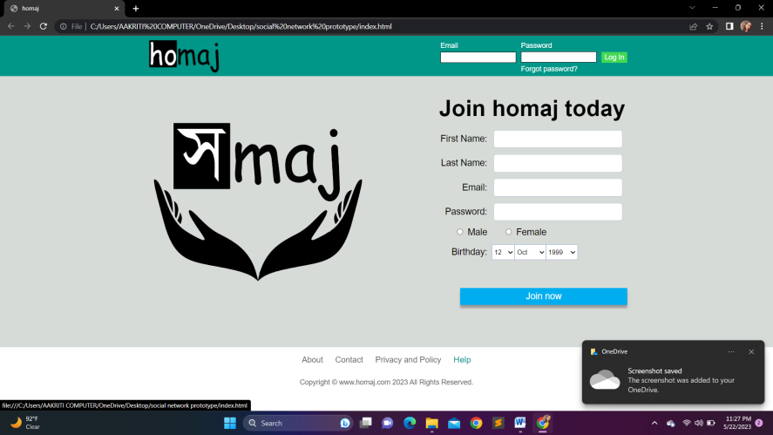

Fig.1

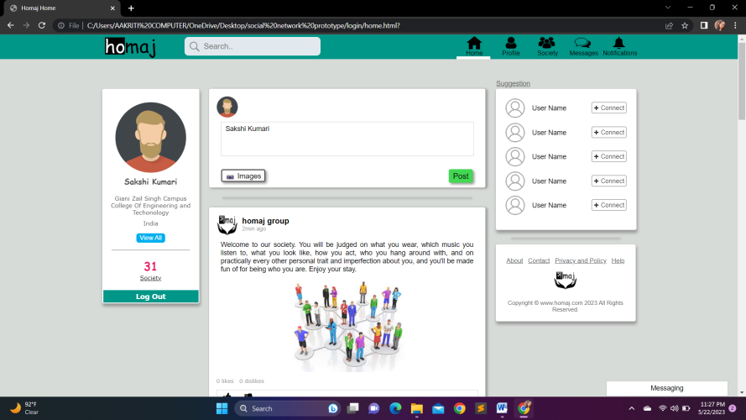

Fig.2

Profile Page:

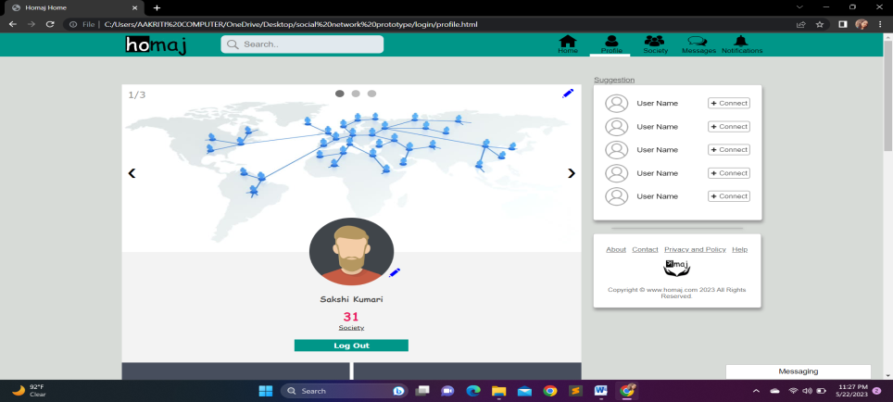

Fig.3

Society Page:

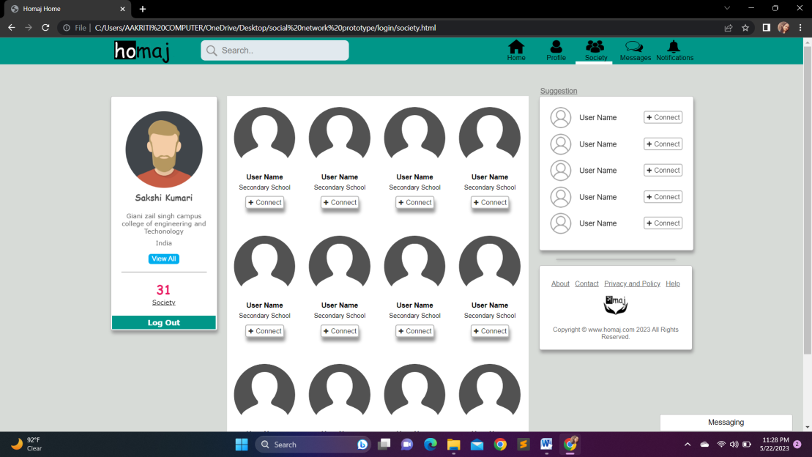

Fig.4

Messages Page:

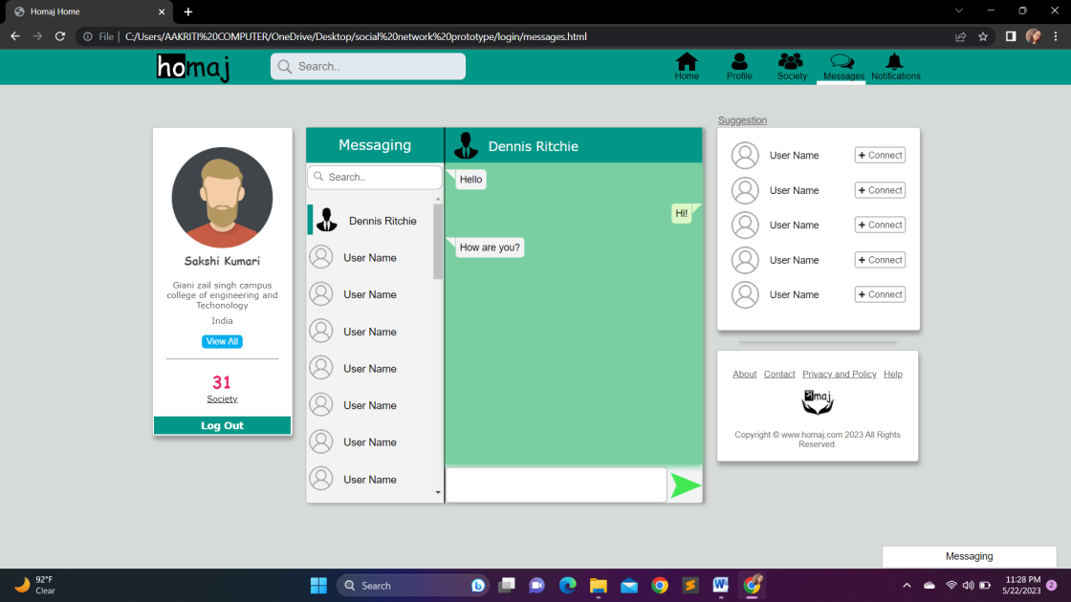

Fig.5

Notifications Page:

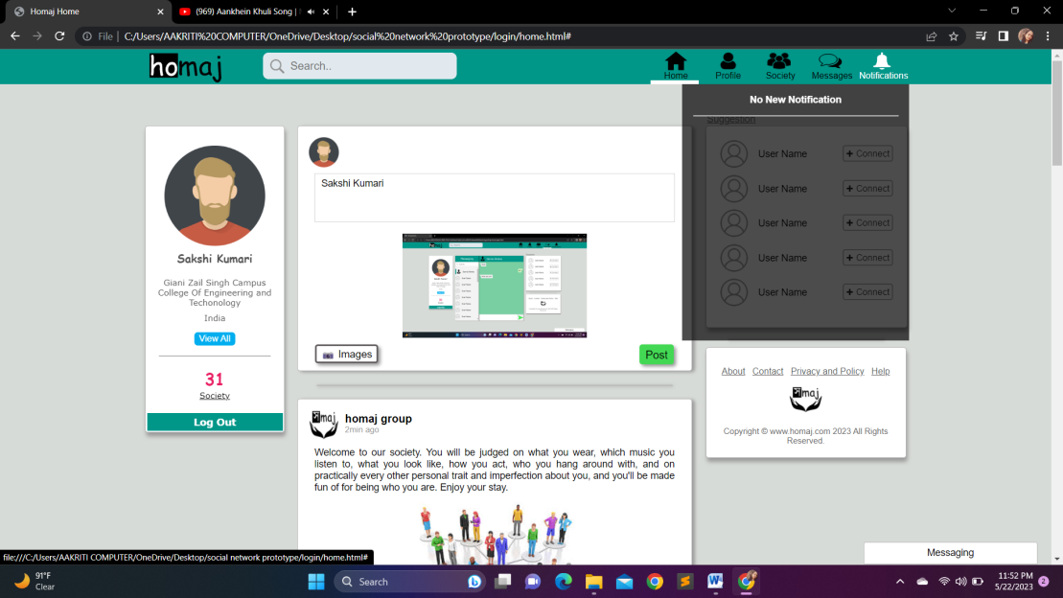

Fig.6

## CONCLUSION

This Network Prototype is in full JavaScript and HTML. Talking about the project, it contains a user side from where a user can view, share a post, photos and many more. The users play an important role in the management of this social media site. In this project, all the main functions have to be performed from the user side.This is a simple demo model for social media sites. You can use session storage and local storage function to set the data as default value.

At last I want to thanks my mentors and parents who helped me a lot in completing this project. This Project would be very helpful form me in my future.

## BIBLIOGRAPHY

▶ <https://www.youtube.com/>

▶ <https://github.com/>

▶ <https://www.w3schools.com/>